Summary of Data from Laudato Si Year Action Plan Evaluation
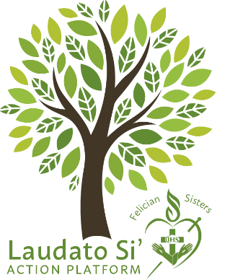
Thank you for responding to the Laudato Si’ Action Plan Year 1 Evaluation. The Laudato Si’ Action Platform Committee received 312 responses.
The Laudato Si’ Action Platform (LSAP) is a seven-year program that is intended to move us towards conversion and behavior change to better care for our Earth. The results of the evaluation tell us that we are off to a good start!
Of course, it was not possible for each person to accomplish all the Year 1 actions, which is why it was suggested to select one or more practices that could be achieved. With that in mind, the data from the results still clearly demonstrates the positive actions we are taking and will direct us towards our next steps.
There were a few items of interest in the results. Planting flowers and vegetables was not easily accomplished as some do not have the space, can no longer garden, or lost out to the deer and other unwanted visitors. Purchasing products that do not use forced or child labor was a challenge because it is hard to know where what we purchase comes from. The question on personal bias was difficult for some to respond to because the topic was not clearly understood.
Our weakest points are taking the initiative to learn about issues pertaining to any of the LSAP goals, contacting political leaders, learning about local issues, and getting involved in our communities. Perhaps these are some things to consider, on a personal level, as we move into Year 2.
Let’s celebrate all the good practices we have already embraced and encourage others to join us!
The results of the survey were tabulated according to the “Yes” answers to each question on the survey. The percentage demonstrates the respondents that participated in each particular action.
- Used reusable shopping bags – 89%.
- Decreased single use plastic – 85%.
- Ate meatless meals at least once a week– 80%.
- Acted in a manner that defends all forms of life – 94%.
- Helped young and/or elderly in need of assistance – 94%.
- Shared resources and time with someone else in need – 94%.
- Did my best to reduce, reuse, and recycle – 92%
- Was conscious of conserving water and lights – 94%
- Spent time creating a relationship with the Earth and included environmental concerns in my prayer – 72%.
- Changed at least one thing in my consumerist lifestyle – 79%.
- Tried to purchase items that are sustainable – 82%
- Tried to purchase from and support local farmers and businesses – 74%

- Conscious of purchasing items that are child labor or forced labor free – (Many wanted to
know how to tell) – 56%.
- Planted flowers or vegetables – 36%.
- Worked at switching to environmentally friendly cleaning products – 50%.
- Made an effort to learn more about the Laudato Si’ Action Platform – 61%
- Attended a webinar. retreat, or discussion regarding care of the environment – 32%
- Explored my own personal biases using print and multimedia sources. (Many had a question about what this means) - 56%.
- Contacted my political representatives on important environmental issues – 28%.
- Taken time to learn about local issues and have become more active – 30%.
- Joined and/or organized a neighborhood clean-up drive and/or utilized electrical or chemical drop off events- 27%.
- Am active in my community to support important environmental issues – 31%.

